BANK DATABASE

1BM21CS222

create database bank;

use bank;

create table branch(

name varchar(20) primary key,

city varchar(20),

assets real);

create table bank_Account(

account_no int,

branch_name varchar(20) , balance real,

primary key(account_no,branch_name),

foreign key(branch_name) references branch(name));

create table customer(

customer_name varchar(20),

customer_street varchar(20),

city varchar(20));

alter table customer

add primary key(customer_name);

create table depositor(

customer_name varchar(20),

account_no int,

primary key(customer_name,account_no),

foreign key(customer_name) references customer(customer_name) on delete cascade,

foreign key(account_no) references bank_account(account_no) on delete cascade);

create table loan(

loan_no int , branch_name varchar(20) primary key,amount real,

foreign key(branch_name) references branch(name));

select *from customer;

insert into branch values ('SBI_Chamarajpet','Bengalore',50000);

insert into branch values('SBI_ResidencyRoad','Bengalore',10000);

insert into branch values('SBI_ShivajiRoad','Bengalore',20000);

insert into branch values('SBI_ParlimentRoad','Delhi',10000);

insert into branch values('SBI_Jantarmantar','Delhi',20000);

insert into bank_account values (1,'SBI_Chamarajpet',2000);

insert into bank_account values(2,'SBI_ResidencyRoad',5000);

insert into bank_account values(3,'SBI_ShivajiRoad',6000);

insert into bank_account values(4,'SBI_ParlimentRoad',9000);

insert into bank_account values(5,'SBI_Jantarmantar',8000);

insert into bank_account values(6,'SBI_ShivajiRoad',4000);

insert into bank_account values(8,'SBI_ResidencyRoad',4000);

insert into bank_account values(9,'SBI_ParlimentRoad',3000);

insert into bank_account values(10,'SBI_ResidencyRoad',5000);

insert into bank_account values(11,'SBI_Jantarmantar',2000);

insert into customer values ('Avinash','Bull_Temple_Road','Bangalore');

insert into customer values('Dinesh','Bannergatta_Road','Bangalore');

insert into customer values('Mohan','NationalCollege_Road','Bangalore');

insert into customer values('Nikil','Akbar_Road','Delhi');

insert into customer values('Ravi','Prithviraj_Road','Delhi');

insert into depositor values('Avinash',1);

insert into depositor values('Dinesh',2);

insert into depositor values('Nikil',4);

insert into depositor values('Ravi',5);

insert into depositor values('Avinash',8);

insert into depositor values('Nikil',9);

insert into depositor values('Dinesh',10);

insert into depositor values('Nikil',11);

insert into loan values(1,'SBI_Chamarajpet',1000);

insert into loan values(2,'SBI_ResidencyRoad',2000);

insert into loan values(3,'SBI_ShivajiRoad',3000);

insert into loan values(4,'SBI_ParlimentRoad',4000);

insert into loan values(5,'SBI_Jantarmantar',5000);

select * from loan;

select * from depositor;

select * from customer;

select * from bank_account;

select * from branch;

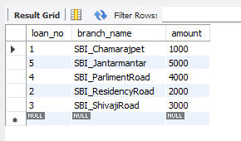

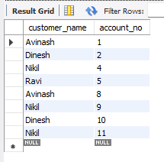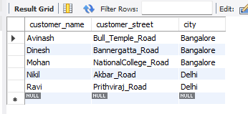

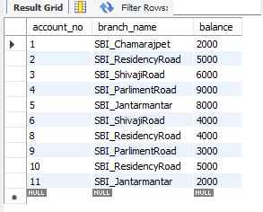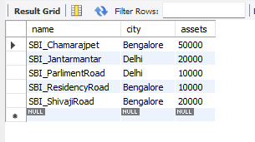

select distinct customer_name

from depositor d, bank_account b

where d.account_no= b.account_no

and branch_name ='SBI_ResidencyRoad'

having count(customer_name)>=2;

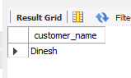

select name,assets/100000 as Asset_In_Lakhs from branch;

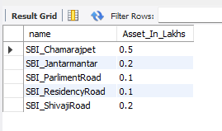

create view loansum as

select branch_name,sum(amount)

from loan

group by branch_name;

SELECT * FROM loansum;

